Lab 2 Worksheet Relative and Radiometric Dating Spring 2018
Name ______ (-2 points if missing)
Date _______
Use your lab book, lab and lecture PowerPoints, and internet as needed to answer all questions in each of the 2 parts. Please explain everything in your own words.
Part 1 Relative Dating Using Figure 1.6, fill in the blanks on the side of each diagram to place the sequence of events in order from oldest at the bottom to youngest at the top. **Handwrite the order of events, type all other answer in. Take digital image, copy into this document for submission.
Using Figure 1.7 in lab book, answer the following questions.
- What is the oldest unit in the Grand Canyon?

- What is the oldest sedimentary unit in the Grand Canyon?

- What is the youngest Precambrian unit in the Grand Canyon?

- What is the oldest Paleozoic unit in the Grand Canyon?

- What is the name and lithology of the youngest formation?

- What formations comprise the Cambrian system in this area?

- Visually trace the unconformity at the base of the Tapeats Sandstone from left to right across the diagram. What is different about the nature of the unconformity from west to east?

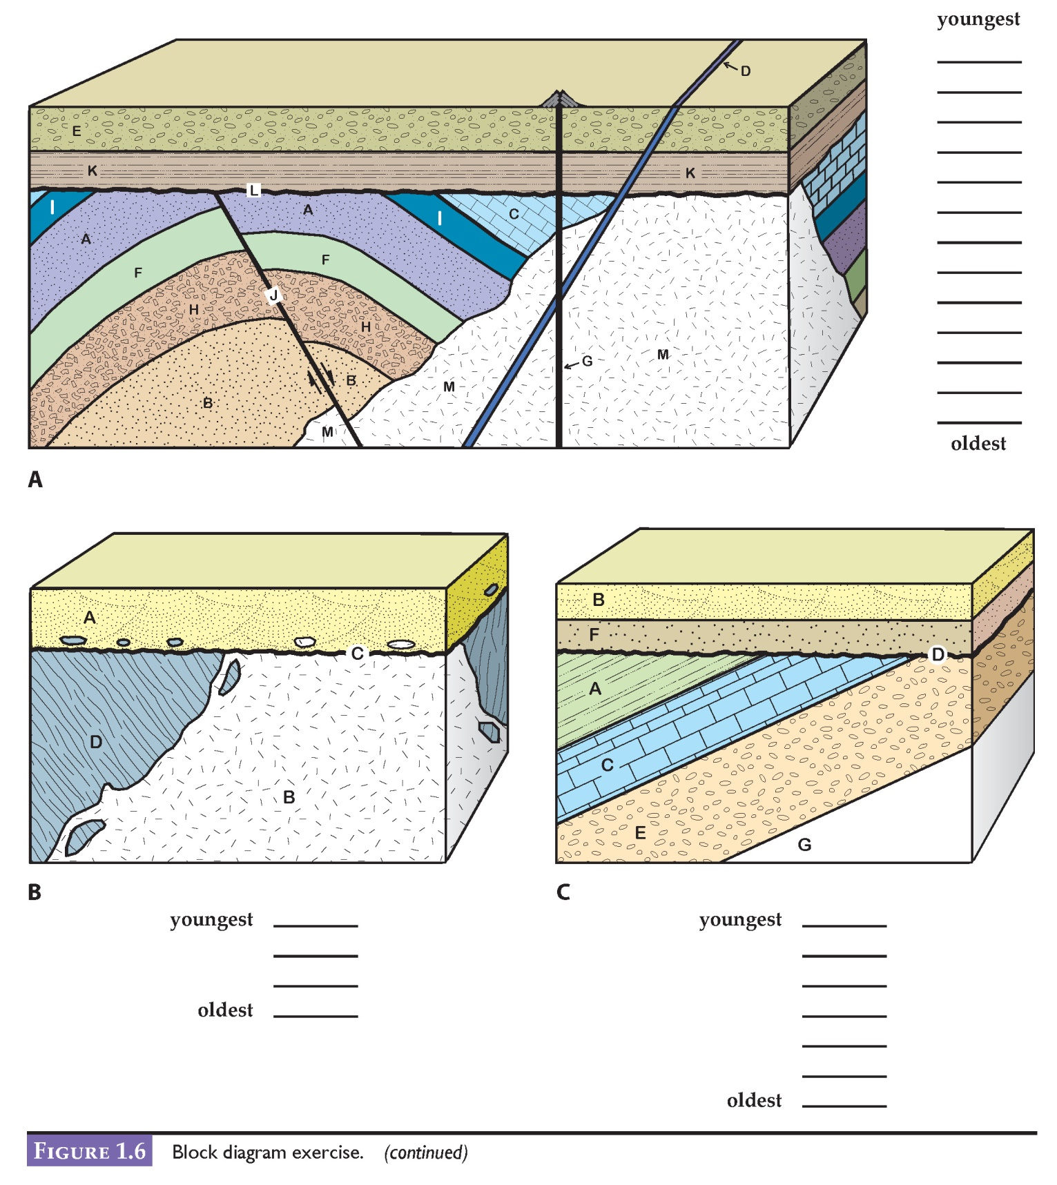

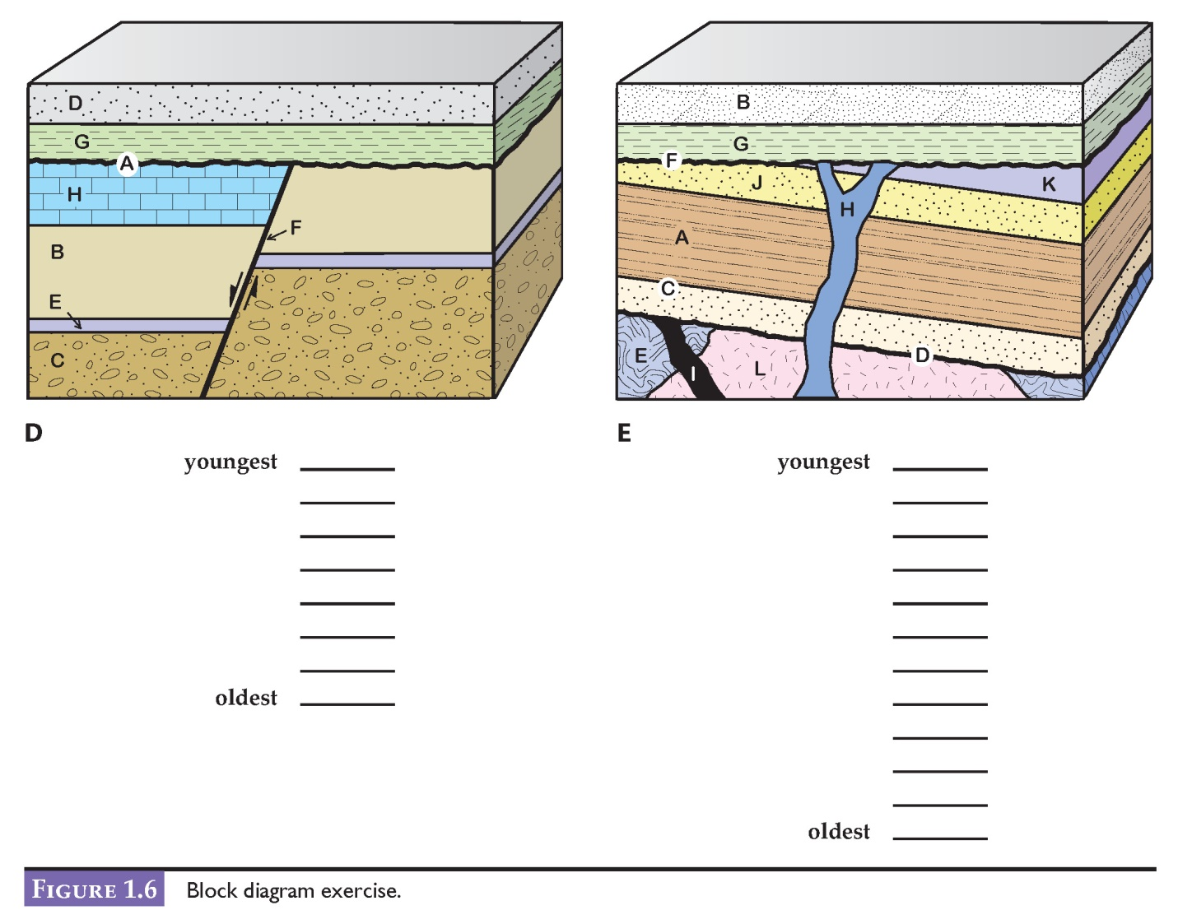
Part 2 Radiometric Dating
Use the help in the Lab 2 PowerPoint, and table 2.2 on page 22, complete the graphs below. Use graphs to plot data. Take a digital image of your graphs. Paste into this document.
After completing the charts below as explained in the Lab 2 PowerPoint, answer the following questions.
- What is YOUR calculated age for the Carboniferous/Permian boundary.

- How different is this from Figure 1.1?

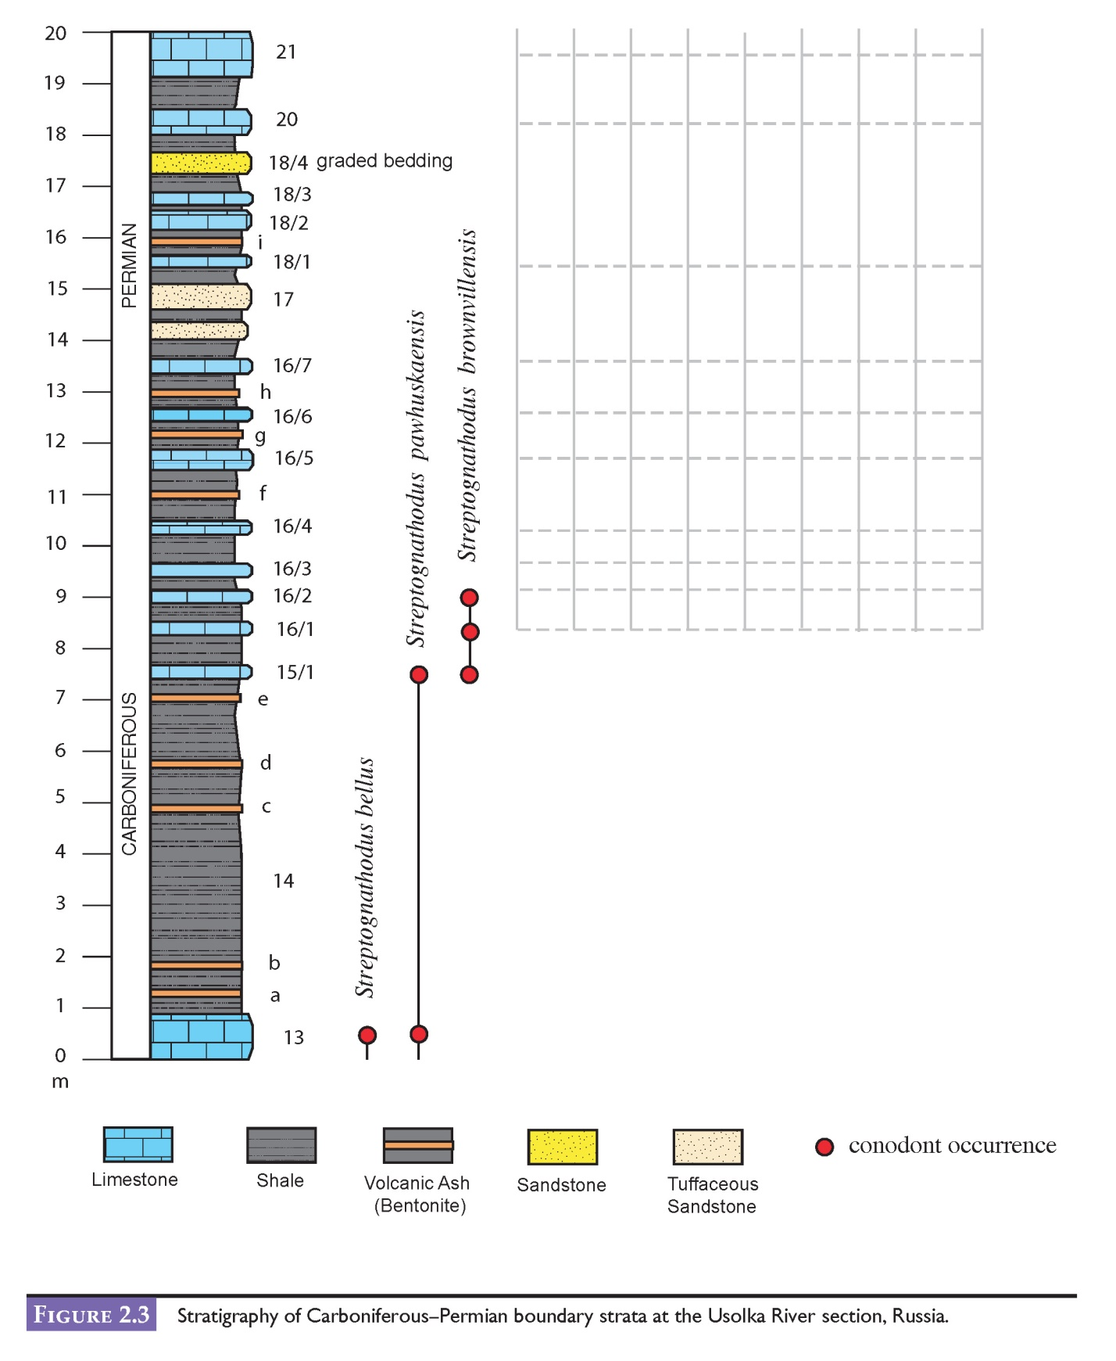
S. brownvillensis →
S. simplex →
S. wabaunsensis →
S. isolatus →
S. cristellaris →
S. longissimus →
S. constrictus →
S. barskovi →

